**Tommy MacKay’s Royal Institution Address: 26 September 2013**

**‘Can Psychology Change the World? And why hasn’t it?’**

A decade ago when I gave my Presidential Address to the British Psychological Society my title was ‘The Future Belongs to Psychology’. I returned for two Award lectures in 2008 and 2011 with the titles, ‘Can Psychology Change the World?’ and ‘Why Tell the World About Psychology?’.

The message was – and remains – a simple one. Not only do I believe that psychology can change the world, but I believe it is uniquely equipped to do so.

In saying this there are two things I am not claiming: first, that psychology can act alone – there is an immense contribution on offer from the other social sciences and from other disciplines; second, that psychology is the ultimate answer to the practical and spiritual needs of humankind – I believe it is not.

To say that psychology is uniquely equipped to change the world we need only look at what psychology is. Psychology is defined by the British Psychological Society as ‘the scientific study of people, the mind and behaviour’. This is the whole point. The main problems facing the world today are *people* problems. They arise from people’s thinking and behaviour.

Some years ago I was asked to do a live broadcast on the radio on what psychology can offer the world. I was to come on immediately after the news and I issued a challenge: let’s listen to today’s news headlines and I’ll tell you why psychology is the answer. The headlines on that occasion were depressingly similar to those you will find in today’s newspapers: war; breakdown in international relations; terrorism; violent crime; the environment and impending catastrophe; the impact of economic recession, especially on the world’s poorest; and, in some ways in stark contrast, the obesity epidemic, especially among children and young people in Western nations.

All of these world issues are a function of human behaviour and relationships. That is, they are ultimately by definition psychological issues. War and terrorism arise from enmity, aggression and alienation, international disputes from the breakdown of relations and failed negotiation, crime from anti-social behaviour and its varied causes, environmental problems – insofar as these are caused by human action – by issues like pollution and waste; the impact of economic recession raises issues of social justice, common humanity and compassion, and obesity concerns human behaviour and choices regarding lifestyle.

Sadly, psychology has the potential not only to be a force for good but a force for evil, as may be illustrated by the headline in the newspaper I was given today on my plane journey here, where a young man had studied psychology text books to find ways of controlling and abusing his victims. However, psychologists are not only working in every single one of these areas, but their work has in my view opened up possibilities with world-changing potential.

It would be impossible to give an overview of this field in a short address, but there have been successful psychological schemes to increase recycling and reduce waste, to reduce crime levels in troubled neighbourhoods, to bring about conflict resolution in some of the most difficult and intractable situations, to promote healthy living and much else besides.

Let me take an example from my own work – the social and economic blight of illiteracy. Every year over 100,000 children and young people leave our UK schools without adequate skills to read and right. This is very significantly higher in the poorest areas. Illiteracy levels are associated in turn with higher levels of classroom disruption, higher crime rates and reduced economic prosperity.

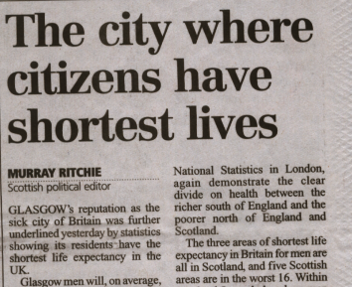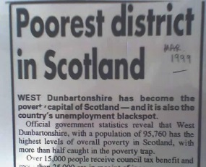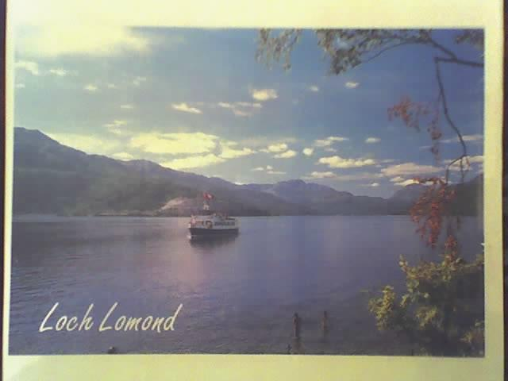I am fortunate in living in one of the world’s beautiful places, not far from the banks of Loch Lomond. Yet it is on the verge of one of the poorest areas in the UK. The nearest city is Glasgow, the city with the lowest level of male longevity in the country, with a full 12 years difference in male mortality between the poorest districts and adjoining wealthier areas.

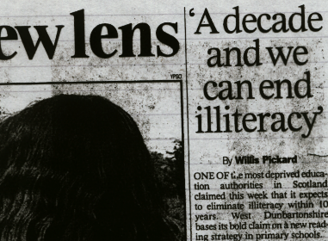In 1996 I approached West Dunbartonshire Council regarding an endemic problem in areas of socio-economic disadvantage – educational underachievement. I proposed to them a great vision – the eradication of illiteracy from the whole population. We began with a bold declaration: we will wipe out illiteracy in 10 years.

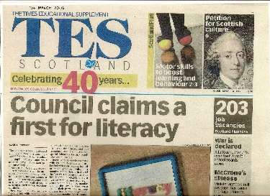It seemed impossible at the time. It had never been done before. But 10 years later, after what was perhaps the most ambitious literacy project in the world, and after the assessment of almost 70,000 children and young people, we achieved our target.



I believe that what psychology can do for illiteracy it can do in almost every other problem area at national and international level.

Yet there is a crucial question to ask. If psychology can change the world, why hasn’t it? We could say that it is because policy-makers and decision-makers do not invite psychology and psychologists to be at the heart of all their plans and committees. Equally we could say that it is because psychology has not made its case well enough to be invited into such a partnership.

Some 20 years ago I received an award from the Chartered Institute of Transport for work in an areas with major importance for the environment and for social justice: psychology and passenger transport policy. I surveyed the chief executive officers of every Passenger Transport Executive in the UK regarding their awareness of work done by psychologists in six key areas of passenger transport policy. The CEO of the UK’s largest PTE on seeing the claimed contribution of psychology asked me, ‘Why haven’t psychologists made their case and become centrally involved in policy here?’ Twenty years later the position has not much changed.

I believe, however, that the answer to why psychology has not changed the world is more complex. Psychology must utilise psychological methodologies for taking successful work done at the *micro* level and applying it at the *macro* level. The West Dunbartonshire Literacy Initiative had its genesis in a successful study on only 16 children in one school. From there we developed a methodology that would work at whole population level. That involved using a whole range of skills from organisational psychology in order to achieve an educational psychology objective.

If we aim to change the world we must do so at the highest levels of its social political and economic structures. I believe the onus is on psychology to develop projects that can rise beyond the local and the small-scale, to aspire to visionary interventions at national and international level. The task in doing so is to convince decision-makers that there is a resource here that can play a major role in making the world a better place.